MAKING A MUSIC VIDEO IN MOVIE MAKER AS A SPECIAL PROJECT FOR SCHOOL
(document created October 18, 2016)
Enrichment projects can be a great way to incorporate technology and make school more interesting for students. This can be an intimidating process, though, without a little extra guidance. Accessible and affordable software can have its glitches.
This document is intended to provide a series of steps that a student can loosely follow in order to create a music video, or other kind of video, in movie maker for a project. Software does undergo changes from time to time, so it will still likely be necessary to ‘play around’ with the program if this is your first time using it.
1) First of all, you will need to decide on a topic for your music video. If you are doing the video for a class, it will have to have some sort of curriculum related educational focus. Brainstorming a number of possible topics might be a good idea, because finding music and photographs or video could be a challenge, so you will need a number of options.
2) If you are doing a slide show style or stop motion music video, it will be necessary to listen to the music, ideally with a copy of the lyrics in hand, and map out when you would like to change photos for the music. One way of doing this is to use a Video Storyboard chart. See document 4b ‘Example Video Storyboard’ under the ‘Educational’ tab at www.arturostreasure.com , with the song ‘Prime Minister’.
3) The second step in the process is to find and choose photographs or other images to suit the video, and to suit whatever educational purposes that your project has. Again, refer to the Example Video Storyboard. You can copy it if you like and use it as a template, erasing the lyrics and time notations and putting in your own for your project.
IMPORTANT
** My son did a stop motion lego video for a school project. He tried to fit 829 photos into one Windows Music Maker project, and it was too much for the program – it kept losing portions of his final project, or would not process everything he wanted to do. That doesn’t make this kind of project impossible; what you have to do is break it into smaller parts and make a video project out of each part. Then, you can piece together the parts to make a larger whole. Windows Movie Maker finds it simple to piece together 3 videos that are not too long, but too complex to piece together 829 photos, even if the project takes the same length of time. Besides, if Movie Maker somehow loses the large project, you still have the small ones to use instead.
**ANOTHER HINT
If you are taking photos yourself, and going the stop-motion route, you should make sure to set up the camera carefully so that there is nothing distracting to photo-bomb your images in the background. You should use a steady surface, ideally a tripod, and make sure your camera is focusing on what you want it to. Otherwise, you will have quite a few blurry photos, and your project will not have the clean and impressive look you want.
4) The easiest way to transfer the photos to your video file in Movie Maker, is to rename them and organize them in their own file in sequence, so that you can transfer them all in order. After that, all you will need to do is copy and paste the entire file into your Movie Maker project (or projects), and adjust the duration of the photos to suit their placement according to the lyrics.
Here’s an example from a screen shot for my Prime Minister music video;
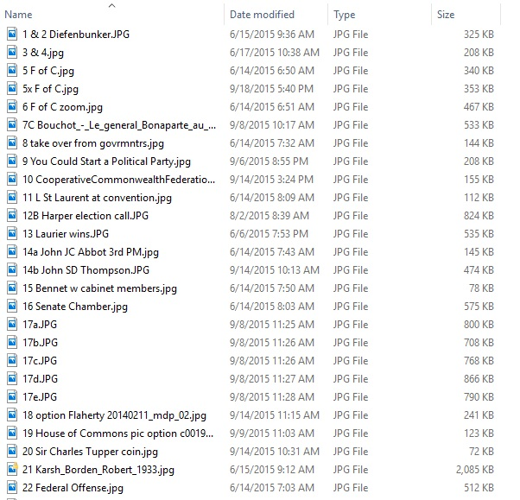

**You’ll notice #18 was labelled ‘option’. Sometimes, out of courtesy, I asked photographers or publications for permission to use their photos. (It’s out of courtesy because copyright laws do allow for a limited amount of copying, provided it is for educational purposes and credit is given to the photographer). Sometimes I thought another photo might be more suitable, but I wasn’t certain that such a photo would be available. It actually can take quite a while to legally choose and use photos, especially if you are not the photographer, so give yourself lots of time and get started early. Anyway, it doesn’t hurt to give yourself a few options for a photo, and then you can make a decision once you know what is possible.
5) In Movie Maker, it’s best to start out pasting the images in, and then to add music. Otherwise, the music will only go as far as the duration of the images, because it is the images that Movie Maker is most concerned with. So, however many images you choose, you should do some math and make sure that all the images together last as least as long as the music does. Here’s an image of the open screen when you select Movie Maker.
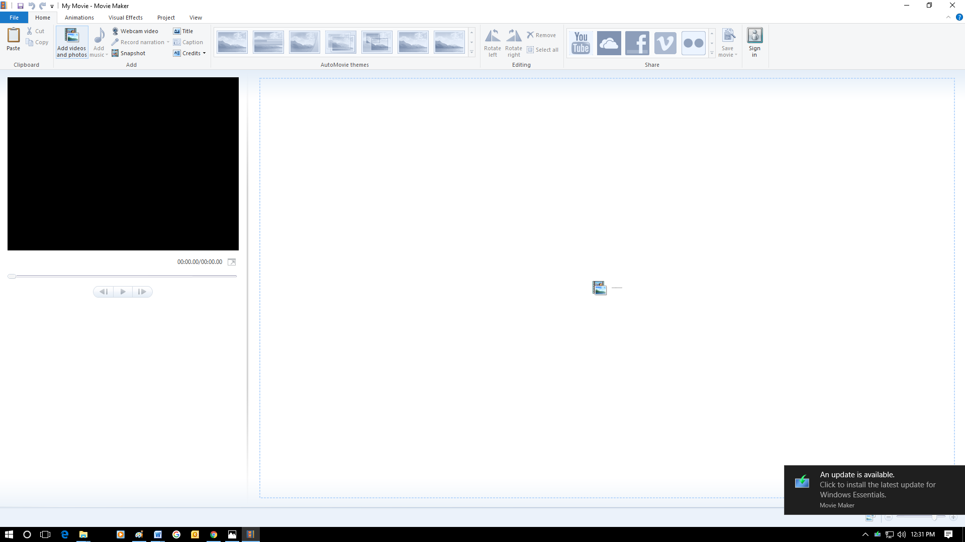

If you look at the top left section of the screen, find the part that says ‘Add Videos or Photos’. That is where you start.

After you have added video or photos, the option of adding music comes up. Here’s an example – I just grabbed a random photo of one of my sons when he was little, holding up a lego creation he was proud of. If you look again near the left top corner of the screen, you can see the ‘add music’ option.
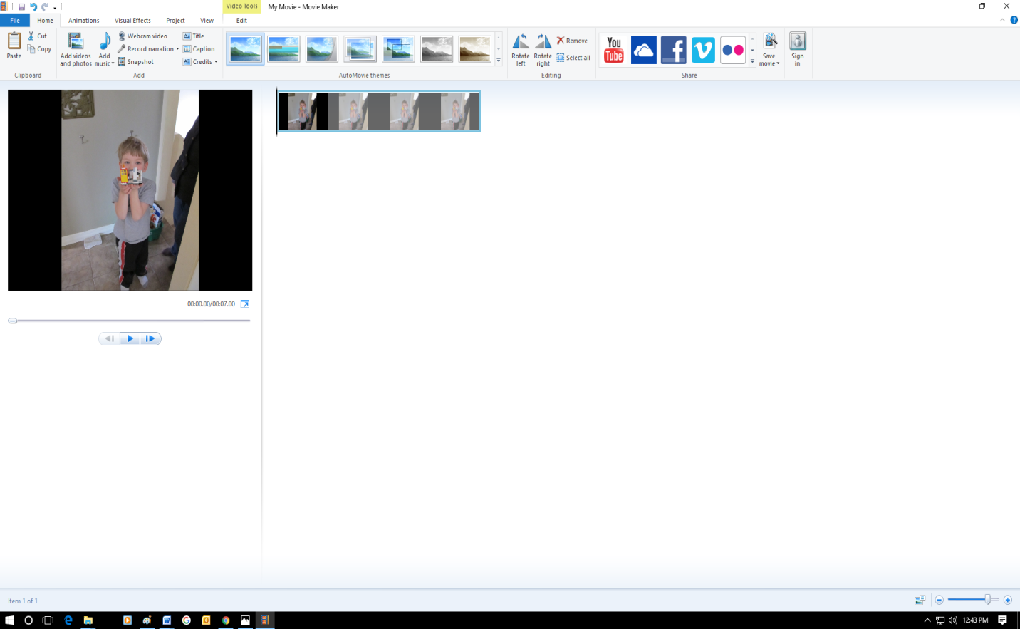

For setting the ‘duration’ of the images you choose, you select the relevant photos and click on the ‘edit’ tab. The following screen will come up;
Notice, I circled the ‘duration’ section for you in red and put in a big arrow in the following image. If you really wanted to, you could choose one photo to represent your entire song, and set the duration of that photo for the full length of the song.
The beauty of Movie Maker, as well, is that if you have the necessary accounts set up you are able to create YouTube videos and stuff for FaceBook and whatnot too.

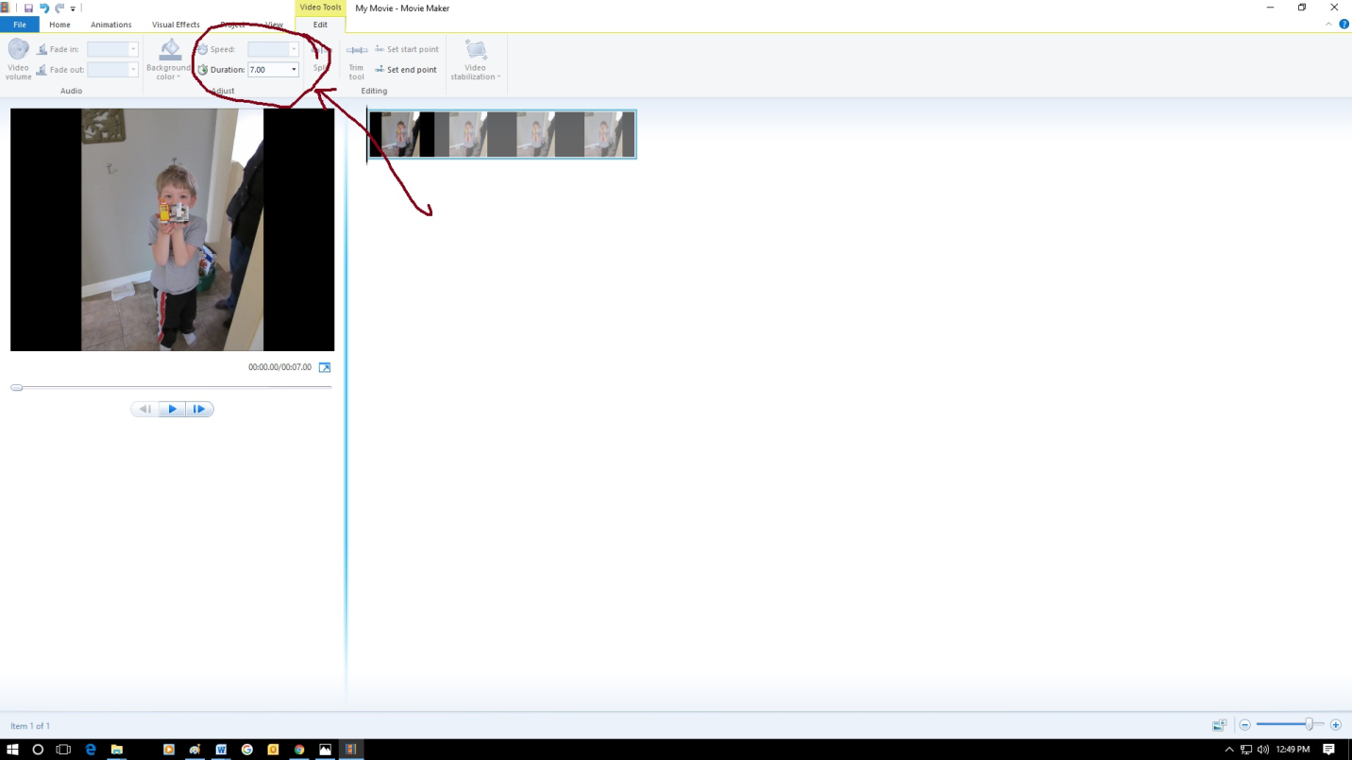

Your should regularly save your ‘Movie Maker’ project. It’s not a bad idea to save a few versions of it – that way, if change your mind about something halfway through, you can easily enough go back to a previous version rather than muddle through the whole thing.
Once you have completed your Movie Maker project, you need to ‘Save Movie’ to your computer, in order to put it in an MP4 format that any computer can read regardless of whether it’s a Windows or a Mac machine. This will improve the chances that a teacher will be able to read and mark the thing. For that, you click on the file tab, scroll down to ‘Save Movie’, and the following is what you will be able to see;
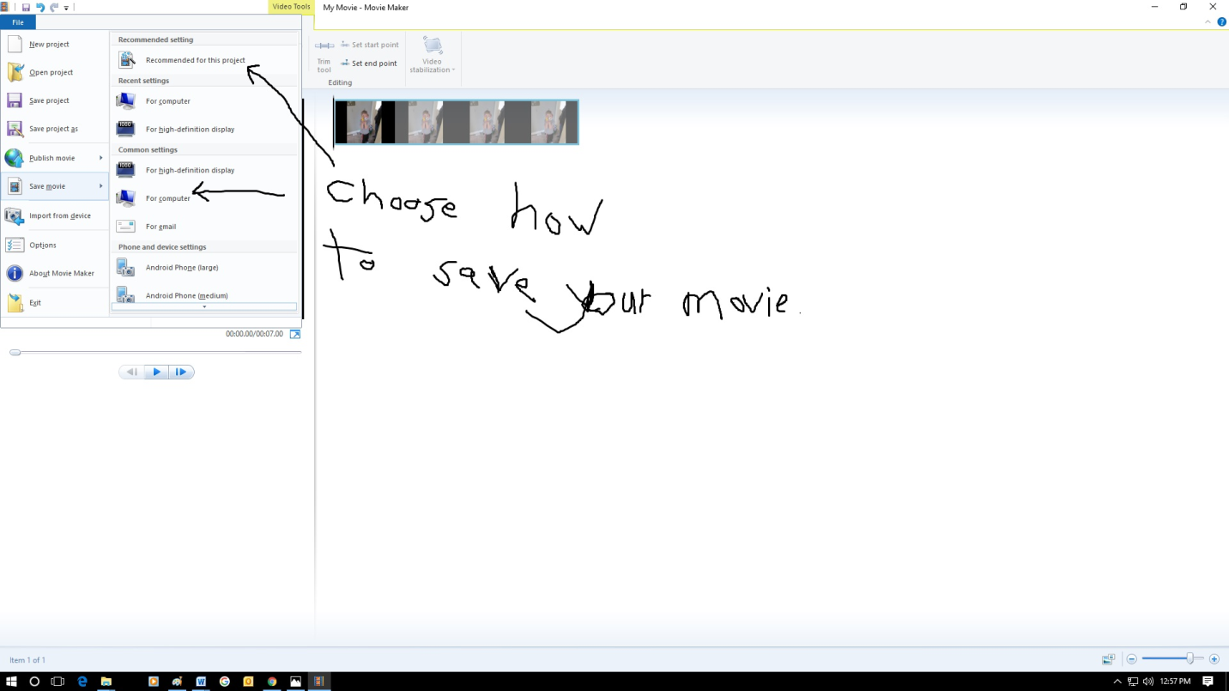

Again, I made my own arrows and messy writing to draw your attention to choices for how to save your movie. You may want to save it at a variety of settings, just in case your teacher only has a limited software or computer processing capacity available for viewing it.
And that’s that, for now. Eventually I’ll get organized and put together a YouTube ‘How To’ for this sort of thing, but for now the document will have to do.

